In-Class Exercise (Security Matrix, DCL, and Views)

## How important is this really?

1. Get together with your breakout group for about **5 minutes** and do the following:
   1. Do a Google search on recent data breaches
   2. See who has the highest number of possible data breaches that might include their data (I got tired of counting somewhere around 20 – beat that!)
   3. How many of these data breaches relate to the company’s database?
   4. Research what a SQL Injection attack is and discuss
2. At the end of 5 minutes we’ll come back together and discuss findings and how it relates to today’s topic.

## ERD Model for class

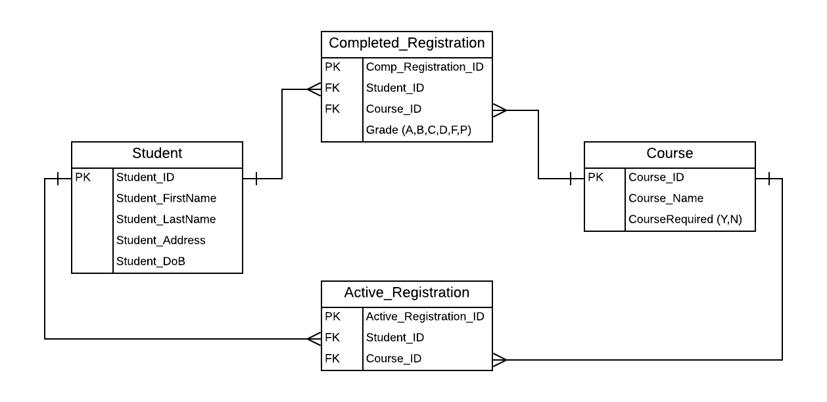

## Security Access Matrix

1 – 3. Fill out what object privilege (S,I,U,D) each role should have for each table. If none, leave blank

|  |  |  |  |  |
| --- | --- | --- | --- | --- |
|  | **Student** | **Course** | **Completed_Reg** | **Active_Reg** |
| **Students** |  |  |  |  |
| **Faculty** |  |  |  |  |
| **Admins** |  |  |  |  |

*Note – for the following questions, your SQL code with return an “insufficient privileges” error, which will show that your syntax is correct even if you do not have admin privileges.

1. Create a Student role called *students* with a default password of password123.
2. Use the Grant statement to assign privileges to the *students* role for Student and Completed_Registration tables.
3. Create a user named fallonj. Then in a separate statement grant the students role to fallonj.
4. Remove a user assigned to a role: remove the student roles from fallonj.

## Views

1. How can you use views to help with data security?
2. Write a view for the RIDE table in the Ride Share context (what you are using for your homework). NOTE: If you don’t have your HW tables created, skip to problem B to use Vendors table from Accounts Payable table set
3. Create a view called ***rider_restricted_info_view*** that shows all ***riders*** but only show the following columns: ***rider_id, first_name, last_name, email,*** *and* ***phone***.

For context: This view is minimizing what columns it shows (i.e. home address). Let’s say that’s for guarding their privacy. Once you create your view see if you can select from it using the SQL: SELECT * FROM rider_restricted_info_view;

1. If you don’t have your homework tables built but you have access to in-class Accounts Payable tables, write a view that returns just the ***vendors*** *from California* but only for their name, address, city, and state. Call the view vendor_ca_only_view